Guide to the Aquila 3D printers at Aabogade 40

Overview

Printer overview 2

Setting up the slicer tool 3

Getting started 6

Changing slicer settings 7

Baby stepping 7

Object placement 8

Filament change 9

Github and good 3D printer practices 10

Troubleshooting 11

Print not sticking to the bed: 11

# Printer overview

A picture of the Voxelab Aquila v2 3D printer can be seen below.

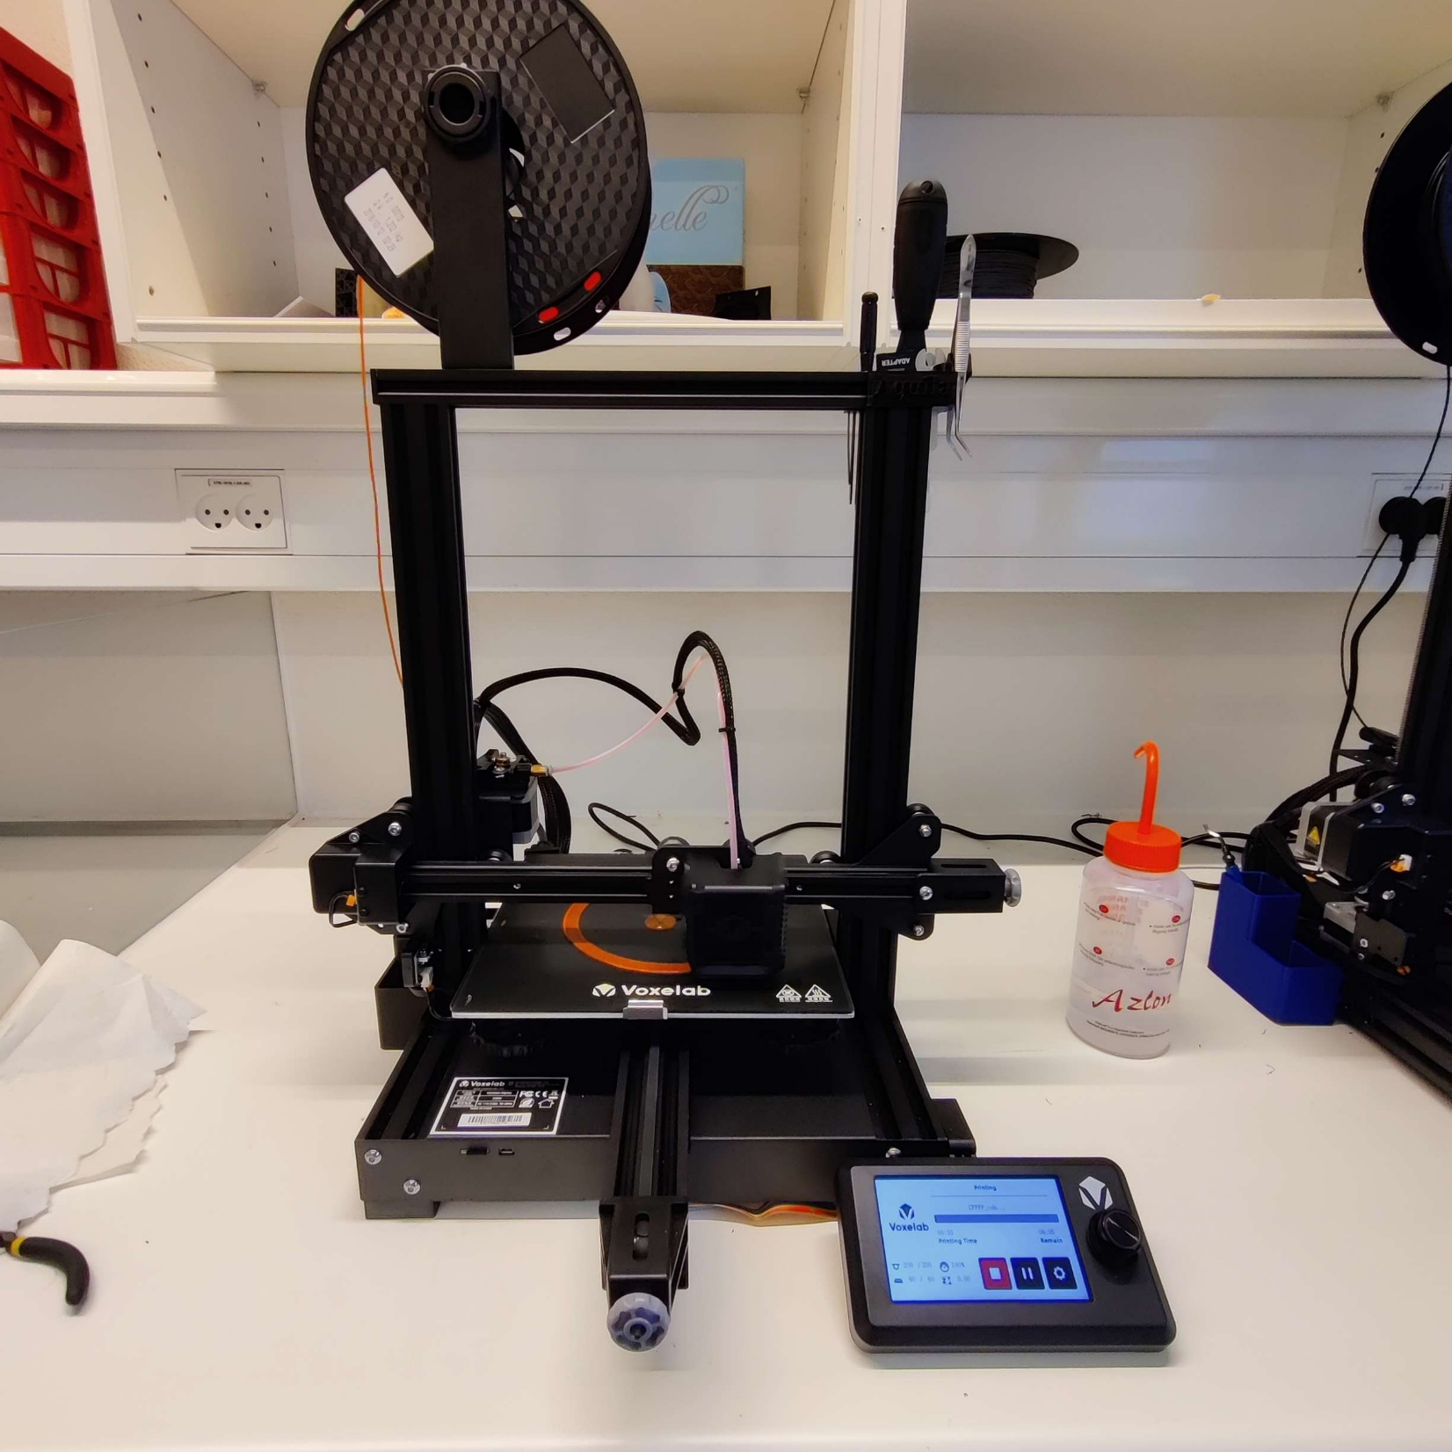

1

2

3

4

5

6

Where **1** is the filament holder loaded with a filament spool, **2** is the tool holder, **3** is the Bowden extruder, **4** is the printer head, **5** is the printer bed and **6** is the LCD display controlled by the knob.

The printer is a copy of the Ender 3 printer. Filament is pushed through the hotend by the Bowden extruder on the bed.

The prints are done by interpreting G-code from a microSD-card.

# Setting up the slicer tool

To use this 3D printer, first install the latest version of [UltiMaker Cura](https://ultimaker.com/software/ultimaker-cura), a slicing tool for 3D drawings.

Next is to install the custom designed Aquila Voxlab 3D printing profile by following the **7** steps shown below

1. Get the printer profile from the micro SD-card, which is either in the toolbox or the printer
2. Open Cura and go to **Add Printer**

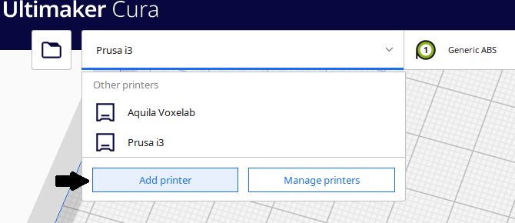

1. Chose the non UltiMaker printer

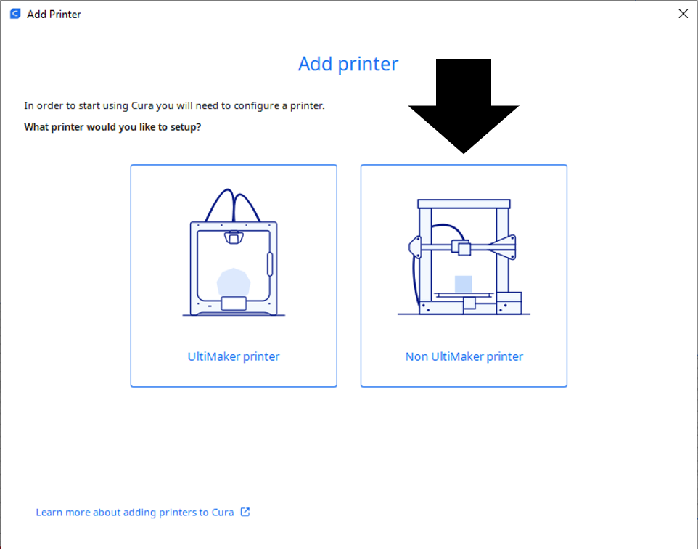

1. 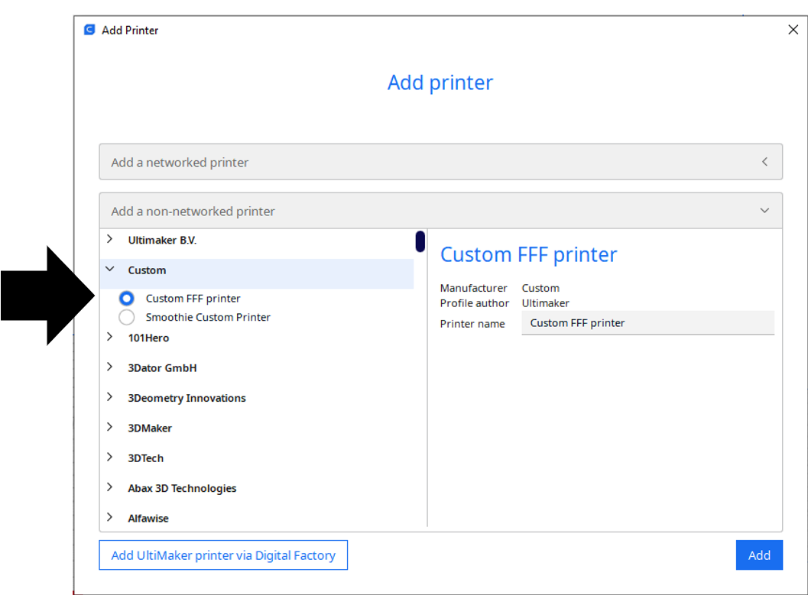Select **Custom Printer FFF (second option from the top),** rename to **Voxelab Aquila,**then **Add**
2. Go to **Manage Printer>Machine Setting**

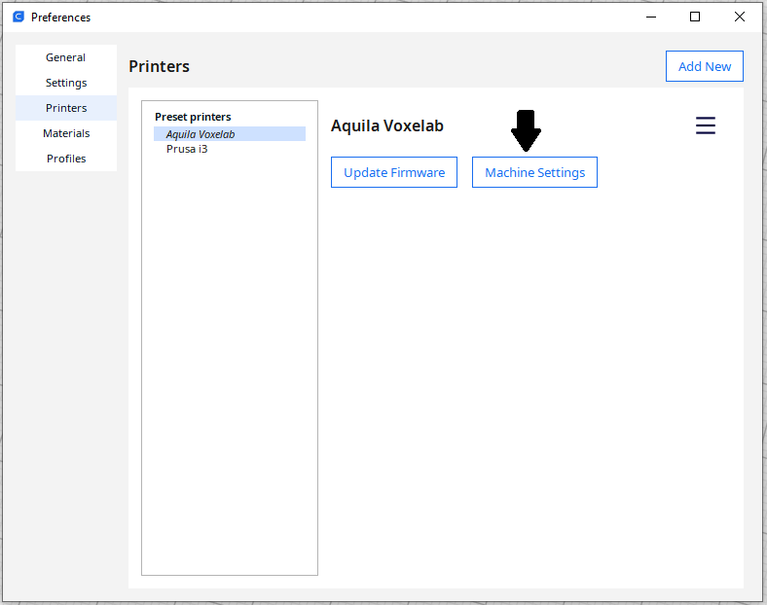

1. 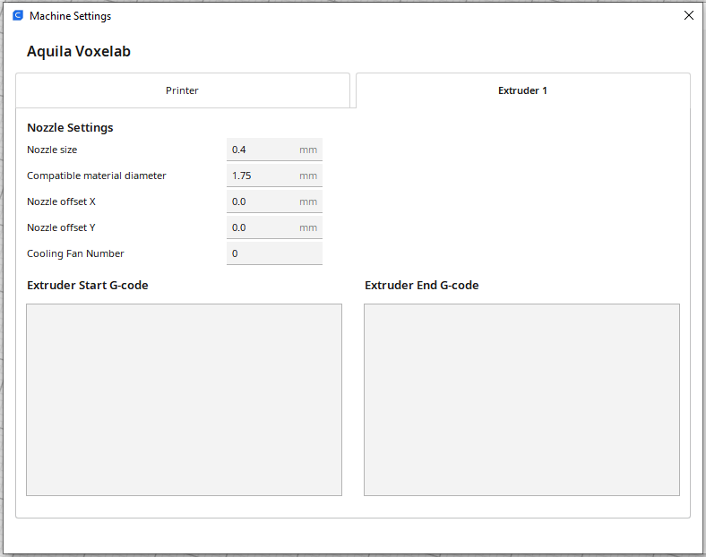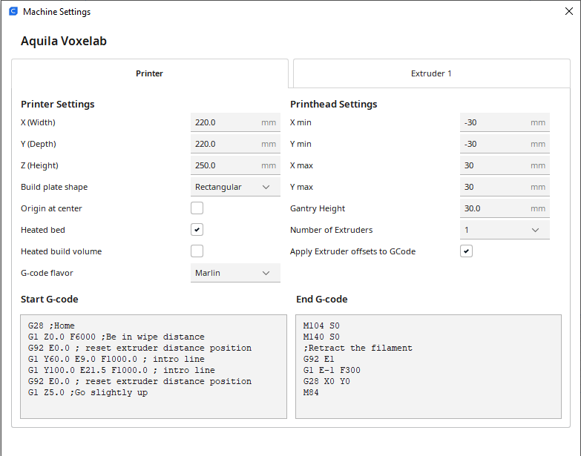Apply these settings

Start G-code:

**G28 ;Home**

**G1 Z0.0 F6000 ;Be in wipe distance**

**G92 E0.0 ; reset extruder distance position**

**G1 Y60.0 E9.0 F1000.0 ; intro line**

**G1 Y100.0 E21.5 F1000.0 ; intro line**

**G92 E0.0 ; reset extruder distance position**

**G1 Z5.0 ;Go slightly up**

End G-code:

**M104 S0**

**M140 S0**

**G92 E1 ;Retract the filament**

**G1 E-1 F300**

**G28 X0 Y0**

**M84**

1. Go to **Manage Printer>Profiles** and import the printing profile you got from the SD-card

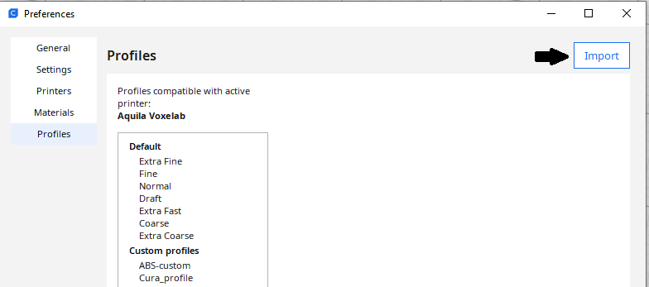

# Getting started

Upload the file by pressing the folder button in the top left corner or simply drag and drop your .stl file in Cura

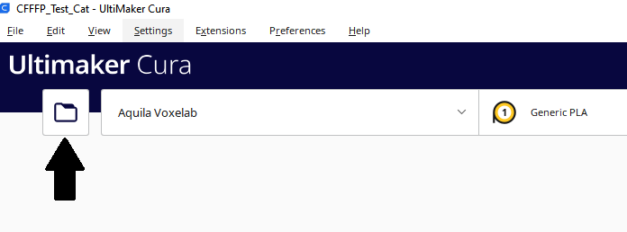

Change the settings as needed, see *changing settings*

Press the slice button at the bottom right corner, when done with the settings.

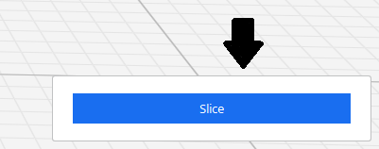

Save to the microSD-card and eject it.

Place the microSD-card into the printer in the slot found on the left side on the printer.

Turn on the printer

By using the knob, press down on the print category on the printer.

Find your print by turning the knob and then press down to start the print.

The 3D printer will start printing the build plate adhesion first either brim or skirt.   
**Important note:** This is where you do the baby-stepping, which needs to be done!

If you immediately can see that there either is a problem with the print being wrong or the 3D printer not behaving correctly press the knob down again twice and you can stop the print.

If the problem is the 3D printer please see *Troubleshooting*

## Changing slicer settings

While there are a lot of settings that you can configure in Cura, please refrain from changing more than the basic settings. Usually, you won’t need to change more than Layer height, infill, support and nozzle temperature to get your desired result. With infill density it is important to remember that it barely impacts the strength of the print beyond the 50% point and usually as low as 10% is enough.

The settings should be changed within the range given below:

Layer height: 0.1 – 0.4 mm

Infill Density: 5 – 50 %

Infill Pattern: Any type you want

Support: on – off

Support type: Tree

Temperature: 190 – 210 °C

[What type of infill should I use?](https://www.wevolver.com/article/cura-infill-patterns-what-they-are-and-when-to-use-them)

[How do I use support?](https://all3dp.com/2/cura-support-settings-optimize-your-supports/)

## Baby stepping

Baby stepping is when a correctional Z axis calibration is done after the print has been initialized. While the bed leveling is continuously adjusted, errors can happen and sometimes the Z-axis needs to be corrected after the print has started. When the first layer is being put down, please look carefull that the nozzle is neither too close nor too far away from the bed. An example of the nozzle being too far away can be seen as gaps in the first layer as shown below:

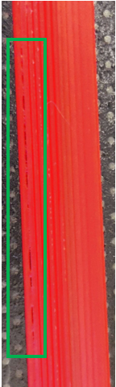

To correct this during the print go to the gear symbol on the printer and press the knob, then go to the bottom and find off-set Z axis and press the knob. You can then adjust the nozzle distance to the bed by either increasing (positive) or decreasing (negative) the distance in increments of 0.01 mm. Follow the [Information post about nozzle height](https://1.bp.blogspot.com/-3xmubC2tibQ/XTMRWdUBy5I/AAAAAAAAJb0/ehE1RTpabpAiv7Y0MQxZ59fkY62LbtFTgCLcBGAs/s1600/3d%2Bprinting%2Bbed%2Bleveling%2Bguide.jpg) to get the best results.

## Object placement

When working in the slicer it is important to understand the limits of the printer bed. At the perimeter of the bed there is worse bed adhesion when compared to the middle. The reason is likely a mixture of only having a single

To show an example of what could happen a test cat has been printed both on the outskirt of the 3D printer and in the middle of the 3D printer, the results can be seen below:

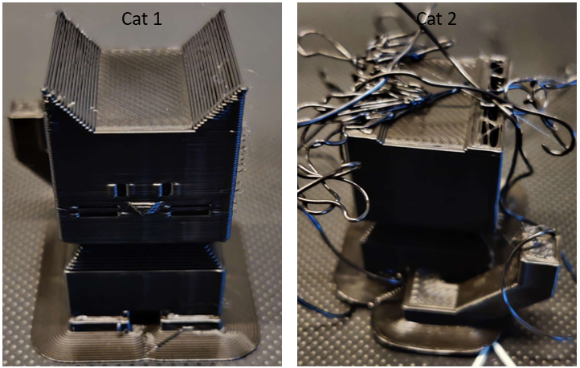

After some time, the bed completely let go of Cat 2 resulting in entanglement of the extruded filament. Therefore, it is very important to understand the bed limitations when either doing a lot of prints or doing a very large print. The placement of both cats can be seen below as well as an estimation of where the bed adhesion becomes worse, however, the exact limits have not been examined extensively.

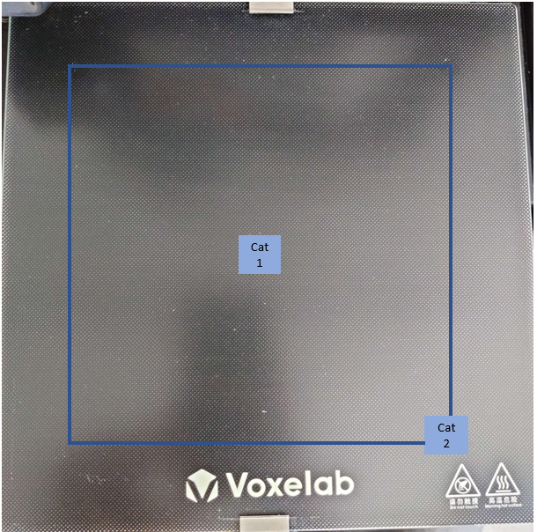

## Filament change

To change filament first go to the control option on the printer by turning the knob. Then choose the filament unload option and wait until the filament has unloaded from the bowden extruder. Then you can exchange the filament by pulling out the filament and removing in the filament holder.

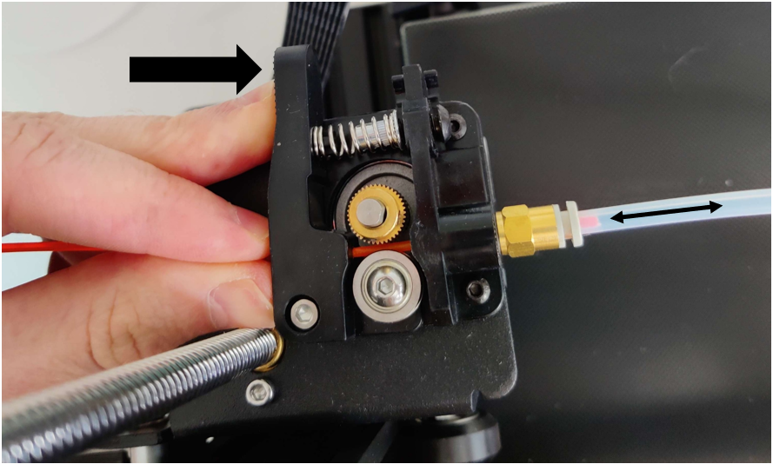

To load in a new filament on the Bowden extruder hold down the shaft and push the new filament through into the PTFE tubing. If you release the shaft it should hold the filament. You can then choose the filament load option from the settings on the printer. See pictures below for a procedure example.

# Github and good 3D printer practices

You can find all the necessary files on the “3D printers Aabogade” github. When using the tools on the 3D printer please put them back and leave it as shown in the picture below:

While you can use the spatula to remove your print, please be very careful as it is easy to scratch the bed surface. Also, after you have removed your print consider quickly wiping the printer bed with a paper and a little bit of ethanol to remove fingerprints as the oil from them worsen the bed adhesion.

The microSD-card should simply be left in the printer and the printer should be turned off after the print is finished. It is a mutual responsibility to keep the 3D printer clean. Keep up to date with the printer profile as it is continuously updated and tweaked to eliminate potential errors and artefacts on the 3D prints.

If you have questions about the 3D printer feel free to contact the current 3D printer super-user(s), however, I(we) **cannot** help with the drawing process.

Thorbjørn : [tbj@bce.au.dk](mailto:tbj@bce.au.dk)

# Troubleshooting

Print not sticking to the bed:

The reason for the 3D print not sticking could either be that the nozzle is too high above the bed or the bed simply has lost some of its gripping ability. The first thing is to try and clean the bed in isopropyl alcohol or ethanol. If that does not work and you suspect bed leveling might be the problem, please read the following link to get an understanding of how bed leveling impacts a 3D print:

[Information post about nozzle height](https://1.bp.blogspot.com/-3xmubC2tibQ/XTMRWdUBy5I/AAAAAAAAJb0/ehE1RTpabpAiv7Y0MQxZ59fkY62LbtFTgCLcBGAs/s1600/3d%2Bprinting%2Bbed%2Bleveling%2Bguide.jpg)

Bed leveling is done by going into control and move the extruder head directly over each of the four bed leveling gears. Remember to move the Z axis 2 mm above the bed when going to a spot, otherwise you might scratch the bed resulting in permanent damage.

Their coordinates are:

**X 25 - Y 30**

**X 195 - Y 30**

**X 25 - Y 200**

**X 195 - Y 200**

Manually readjust each gear until the distance between the nozzle and the bed is 0.1 mm, which corresponds to two A4 sheets. Meaning, if you take two sheets of A4 paper under they should just about go free of the nozzle. Check the bed level by going between each of the gears until you don’t have to readjust them, could be up to 3-4 times.

Test the bed level by using the 3D print “Bed leveling”. The print should show an even print, which sticks to the bed.

[How to calibrate a 3D printer](https://teachingtechyt.github.io/calibration.html#intro)